**TABLE OF CONTENTS**

1. Introduction Page No.
   1. Purpose.................................................................................

1.2 Scope................................................................................................................

1. Software requirement Specification...........................................
   1. Overall Description...............................................................
   2. Specific Requirements.............................................................
      1. Software Requirements
      2. Hardware requirements
      3. Functionality...................................................................
2. Detailed Design
   1. DFD Level 0................................................................................
   2. DFD Level 1.................................................................................
   3. DFD Level 2.................................................................................
3. ER Diagram.........................................................................................
4. Relational Schema and Normalization.................................................
5. Implementation..............................................................................................................
   1. RDBMS Tables and theirs description……………………………………………
   2. Code Snippets……………………………………………………………………
6. Report……………………………………………………………………………….
7. Conclusion and Future Enhancement................................................................................
8. References ……………………………………………………………………………………
9. Appendix: Snapshots.............................................................................................
10. List of Symbols, Abbreviations and Nomenclature…………………..
11. List of Tables………………………………………………………..
12. List of Figures………………………………………………………..

|  |  |
| --- | --- |
| **CONTENTS** | **PAGE NO:** |
| INTRODUCTION | 3 |
| SRS | 4 |
| ER DIAGRAM | 7 |
| DESIGN | 8 |
| RELATIONAL SCHEMA | 14 |
| IMPLEMENTATION | 17 |
| CONCLUSION | 22 |
| FUTURE WORK | 22 |
| REFERENCES | 23 |

**FIGURES:**

|  |  |
| --- | --- |
| **FIGURE NAME** | **PAGE NO.** |
| DFD LEVEL 0 | 5 |
| DFD LEVEL 1 | 5 |
| DFD LEVEL 2 | 6 |
| ER DIAGRAM | 7 |
| RTO MODULE ARCHITECTURE | 8 |
| TRAFFIC POLICE MODULE | 9 |
| CIVIL POLICE MODULE | 10 |
| FLOW CHART | 13 |

**INTRODUCTION**

**PURPOSE:**

Now a day’s population has become a major factor to be considered as a result the number of vehicle’s are growing by increasing problems of vehicle registration, license registration, emission testing and insurance validity for RTO departments and vehicle related documents verification by traffic police. RTO employees having lot of work burden of making registration, license issue, transfer etc., which requires lot of paper work. As a result people can’t get the things done in right time, which is the waste of time and energy. Similarly the vehicle owner sometimes forgets to carry the license, and forgets the insurance at the time of enquiry.

This paper proposed an approach to solve such problems that is by storing all the information related to vehicle and driver at database by RTO administrator. And an android application is provided to traffic police to retrieve vehicle and license information. We can also add a provision to track a stolen vehicle in this case civil police plays an important role, since a web page will be provided to civil police in order to update the stolen status to the RTO database. This approach is also useful to penalize the offenders, who violate the traffic rules.

Regional Transport Office (RTO) is an Indian government bureau which is responsible for the registration of vehicles and issue of Driver’s License in India. RTO management will be having lot of work regarding registration of vehicles and issue of driver’s license. Similarly the vehicle owner sometimes forgets to carry the license, and forgets the insurance at the time of enquiry. This paper proposed an approach to solve such problems that is by storing all the information related to vehicle and driver at database by RTO administrator.

**SCOPE**:

This application is a service oriented Android application specifically designed for transport department which allows efficiently managing and verifying the documents related to vehicle and license. This project targets to store the information related to vehicle such as insurance, license, emission testing details, personal details of the applier and registration date. This application would be installed in Android phones of traffic police. And it will provide input fields to traffic police to enter the vehicle number as well as license number in order to retrieve the information related to vehicle and license from database. In case of civil police, a web page will be provided where he can update the stolen status of the vehicle to database in order to catch the thief. This application also generates fine and stolen status of vehicle. Hence it is completely service oriented application.

**SOFTWARE REQUIREMENT SPECIFICATION**

**SOFTWARE REQUIREMENTS:**

* HTML
* XAMP SERVER
* PHP

**FUNTIONAL REQUIREMENTS:**

* The server must respond to the requests immediately.
* Should provide user friendly interface.
* Should verify the vehicle number given as input.
* If not found, a proper messqage has to be displayed.

**NON FUNCTIONAL REQUIREMENTS:**

* Performance : since there is is organized storage of data, accessing is faster.
* Scalability : this is a web based application that can be scalable extensively.
* Capacity : capacity can be extended dynamically by extending server capability.
* Availability : application can be accessed in any device anywhere through internet.
* Reliability : user can rely upon the data since database is structurely organized and authority for manipulation is provided only to the admin.
* Maintainability : no maintainability overheads are associated since this is webpage.

**DFDS:**

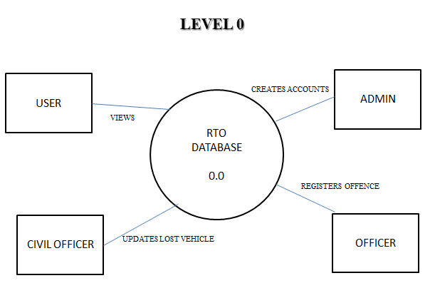

**FIG 1. LEVEL 0 DFD**

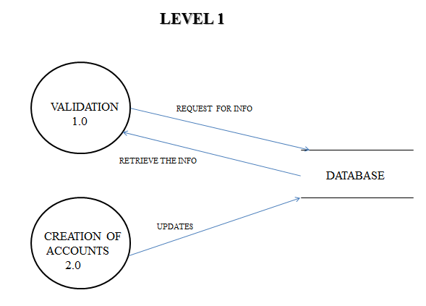

**FIG 2. LEVEL 1 DFD**

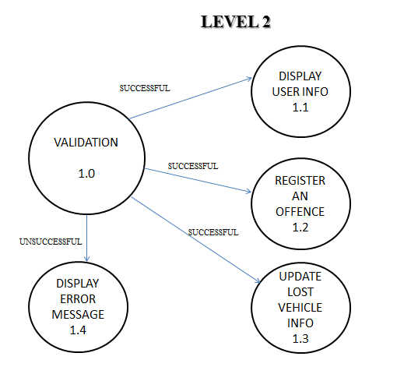

**Fig 3.1. level 2**

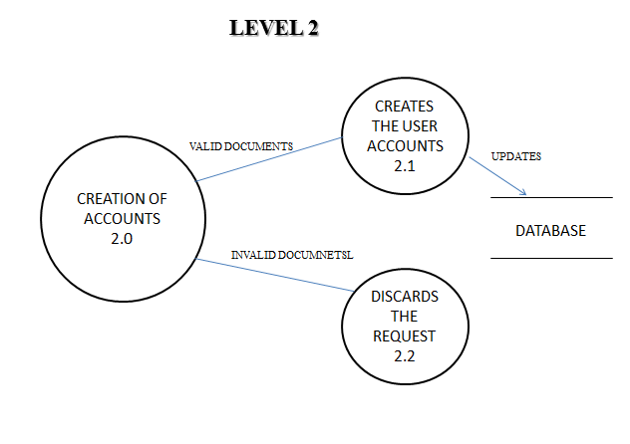

**Fig 3.2. Level 2**

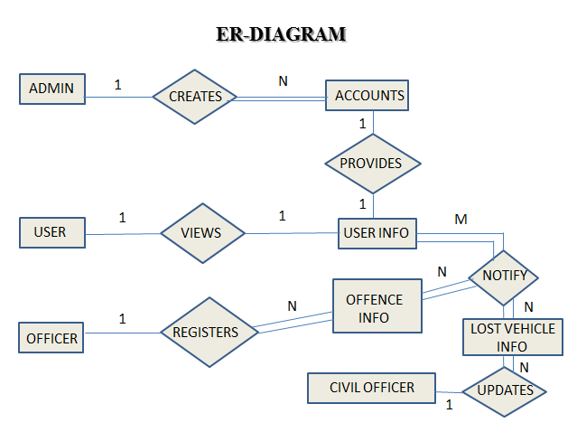

**FIG 3. ER DIAGRAM**

**DESIGN :**

The following architecture design explains the overall working process of this paper here the larger system is decomposed into sub systems. That provides some related set of services. This paper proposes three modules. In which we aim to provide better services. Through android phones and that requires internet for the data transfer. As depicted in Fig. 1 the architecture we can see that a new applier will provide his document’s hard copy forms to the administrator of RTO. This information is stored in database at server through online registration. And server side end is in JSP. On client side an android application will be provided to police. After police logging into the system can retrieve vehicle and license related information from the RTO database. If authentication fails the information is provided to the police to retry else information about the user is displayed. The architecture mainly consists of three modules.

A. RTO module architecture

B. Traffic police module architecture

C. Civil police module architecture

*A. RTO module architecture*

This module is specifically designed for the RTO administrator and it consists of information’s related to the user license and vehicle. This information will be stored in the database.



Fig. 4 RTO module architecture



FIG 5. RTO MODULES

B. Traffic police module architecture

This module mainly focuses on providing the information only to the traffic police officers.

It consists of vehicle information and license information’s. It also generates the fine

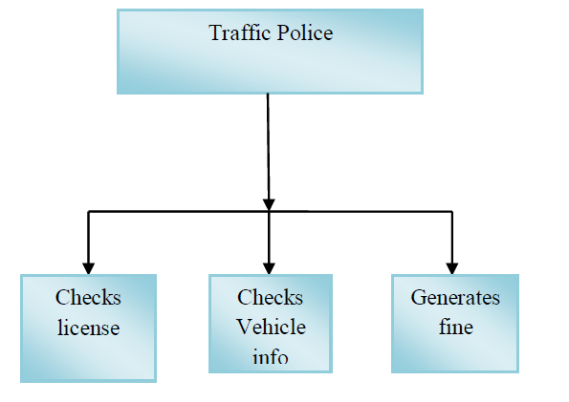

Fig. 6 Traffic police module architecture

C. Civil police module architecture

This module is mainly provided to the civil police officer. It provides a web page to update the stolen status of vehicle.

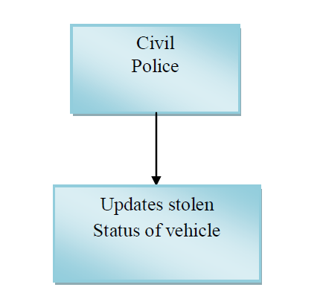

Fig. 7 Civil police module architecture

**SYSTEM MODULES:**

1. **RTO Module**

This is the module where it is mainly used to maintain the vehicle and drivers information. It consists of two sub-modules namely

1. Vehicle info module
2. 2) License info module

*1)* Vehicle info module*:* This vehicle information includes the details like vehicle number, vehicle type, vehicle owner’s name, vehicle name, vehicle owner’s address, owner contact number, vehicle emission date, insurance date, vehicle model name, chassis number, vehicle register date and also it can be responsible for inserting, editing and managing the vehicle related information into the database.

*2)* License info module*:* This license module consists of information regarding drivers personal details like license holder name, license number, license type, DOB (Date of birth), DOI (Date of issue), gender, license vehicle date, license holder blood group, address, age, license holder contact number these all records have to be maintained in the database and also can be editable and manageable by the RTO administrator.

1. **Traffic police module:**

This is the second module of this system. The main advantage of this module is that it helps to generate the fine and retrieve the vehicle and license information’s.

This includes three sub modules.

1) Checks license.

2) Checks vehicle.

3) Generate fine.

1) Checks license:This module takes a license number as input and returns the license information which all are stored in the database like name, photo and type of license, license number ,vehicle type , gender ,DOB,DOI and so on. Incase if records doesn’t exists it shows respective message that indicates the record doesn’t exists.

1. Checks vehicle: Here in this module to check the vehicle related information one must have to give the vehicle number as an input then, the all related records which is stored in the database will be displayed like vehicle number, vehicle type, vehicle owner’s name, vehicle name, vehicle owner’s address, owner contact number, vehicle emission date,

Insurance date, vehicle model name, chassis number and so on. Else in case of records doesn’t exists it shows respective message that indicates the record doesn’t exists

. *3) Generate fine:* This module helps the traffic police officer in generating fines for offences committed and this includes the fields like vehicle number, fine type, amount and reasons for fine.

1. **Civil police module**

This is the third module of the system. This module will be under the responsibility of civil police officer where, this module includes web page to update stolen status of the vehicle and also information like vehicle number, compliant number, complaint details and complainer contact number.

This overall process requires internet for data transfer between the client and server and data which are stored in the server.

The working flow of this paper is as shown in Fig. 5 initially a new applier will provide his document’s hard copy forms to the administrator of RTO. This information is stored in database at server through online registration. On client side an android application will be provided to police. After police logins into the system can retrieve vehicle and license related information from the RTO database. If authentication fails the information is provided to the police to retry else information about the user is displayed.

**FLOW CHART:**

**STEPS:**

Step1: Start.

Step2: Login page will be displayed.

Step3: Authentication is done using RTO database.

Step4: If the person is authenticated then it is categorized into 3 modules.

Step5: a- RTO admin; manages databases (inserting and deletion of information).

b-For traffic police input fields will be provided.

c- Civil police; updates stolen status of vehicle.

Step6: a- RTO admin; will maintain the database.

b- Traffic police queries the given input; if true then fetches information from database else error status will be generated.

c- Civil police; stolen status will be updated in database.

Step7: Result will be displayed. Step8: Stop.



Fig. 8 Flow chart for complete process of verification

**RELATIONAL SCHEMA:**

**ADMIN_INFO :**

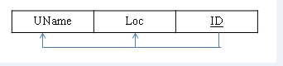

**CIVIL_OFFICER:**

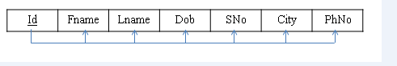

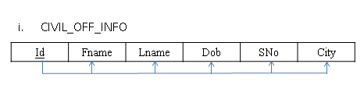

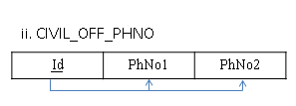

**OFFENCE_INFO:**

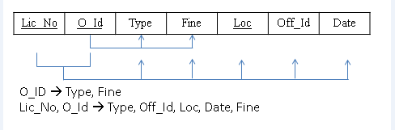

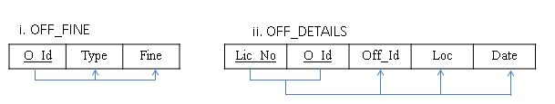

**OFFICER_INFO:**

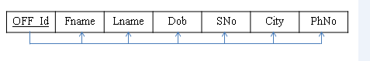

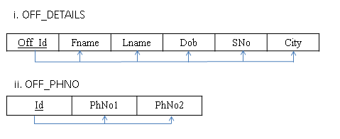

**USER_INFO:**

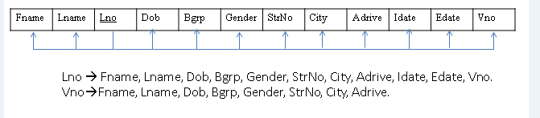

**USER_LOGIN:**

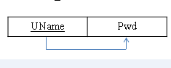

**VEH_UPDATE_INFO:**

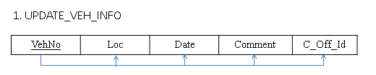

**VEH_INFO :**

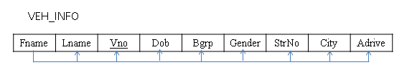

**IMPLEMENTATION**

ADMIN_INFO FORM:

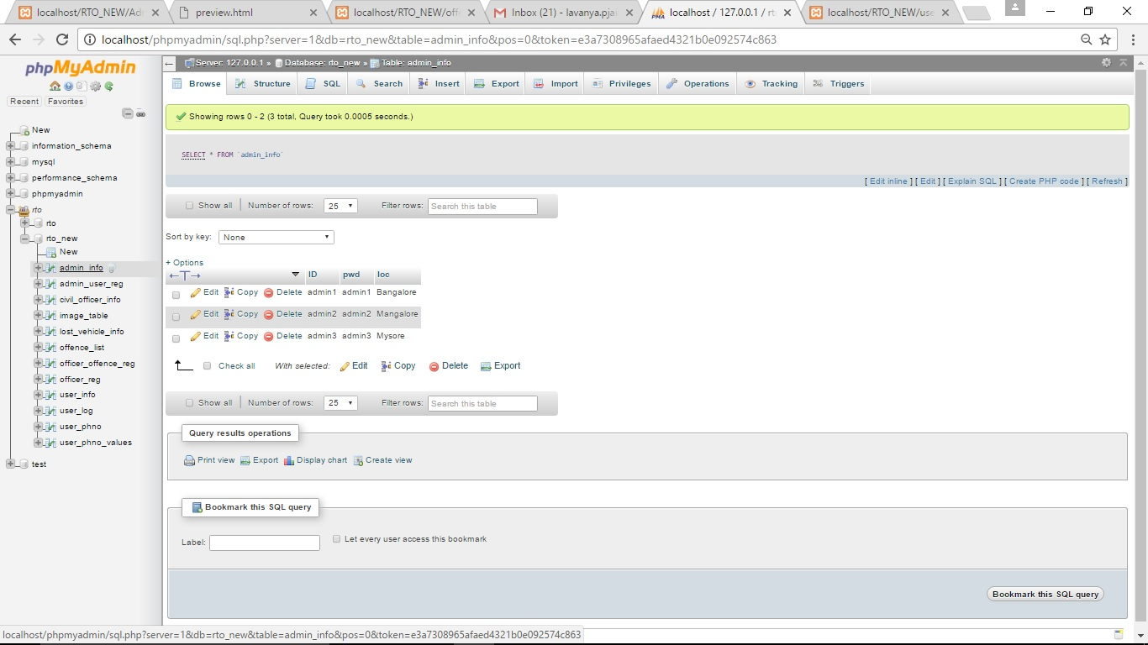

ADMIN_USER_REG FORM:

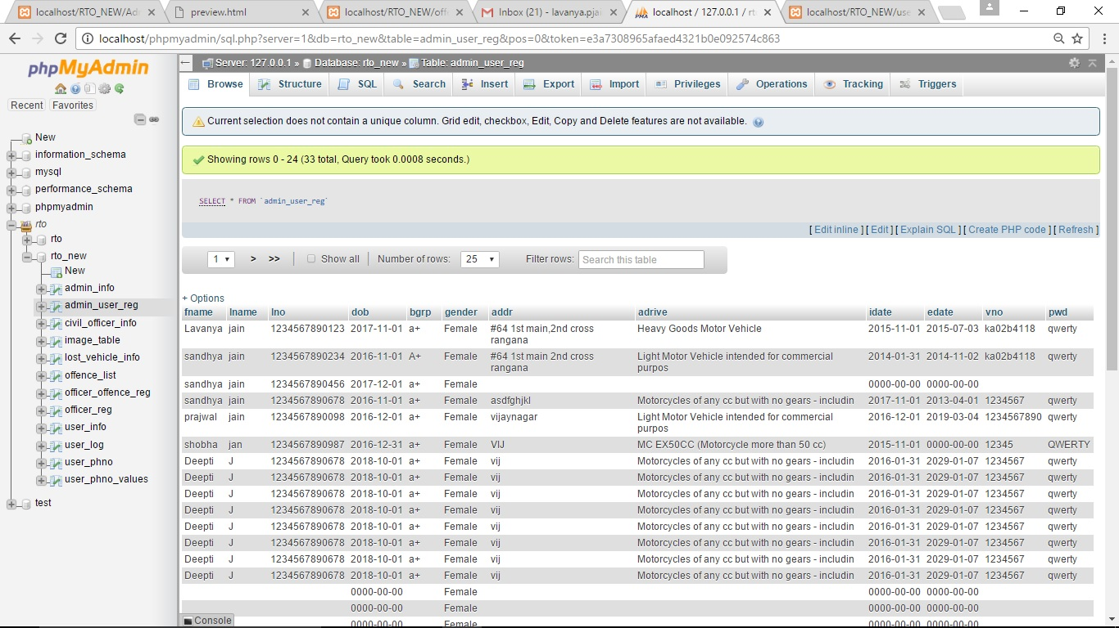

CIVIL_OFFICER_INFO FORM:

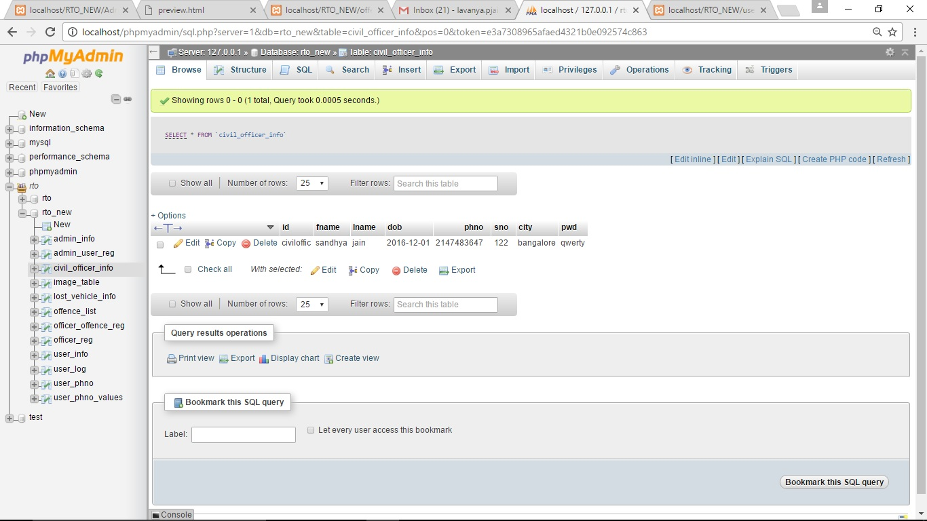

**DATABASE_STRUCTURE FORM:**

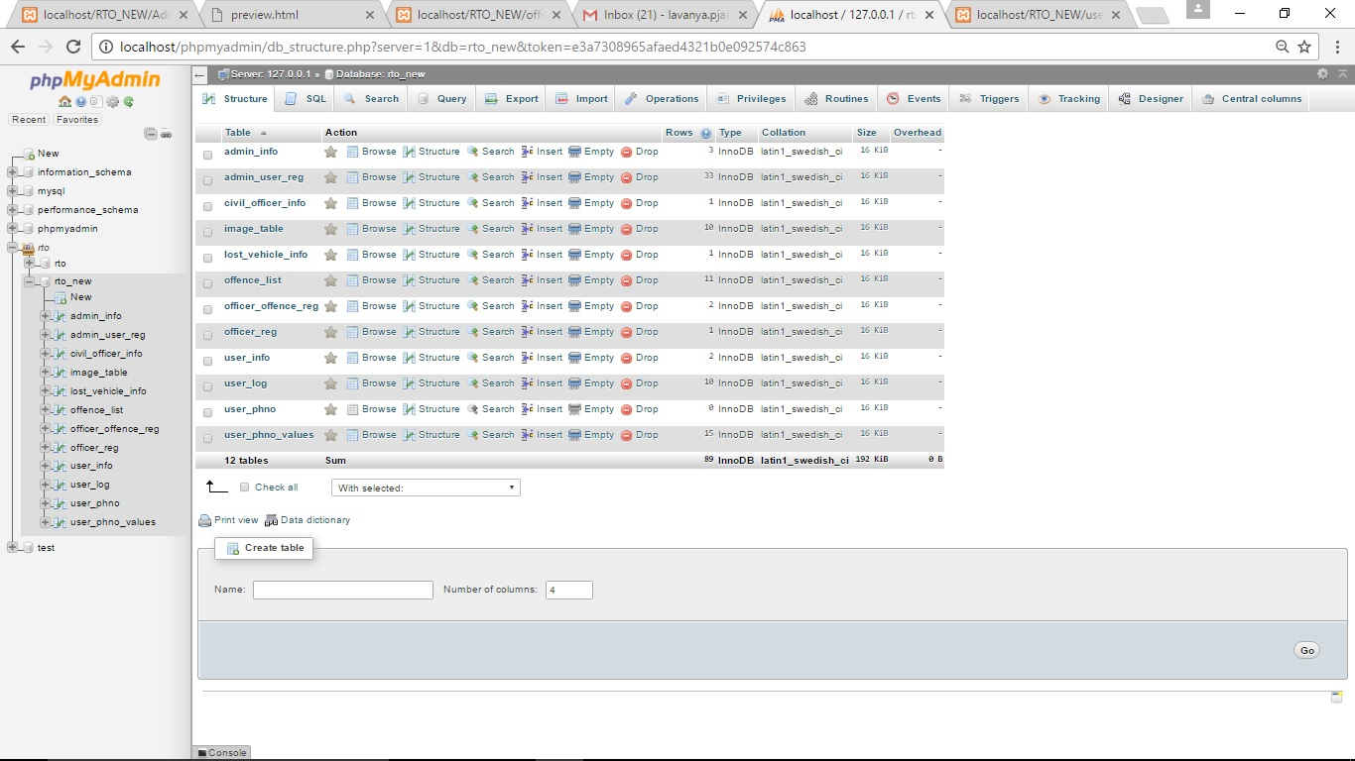

OFFENCE_LIST FORM:

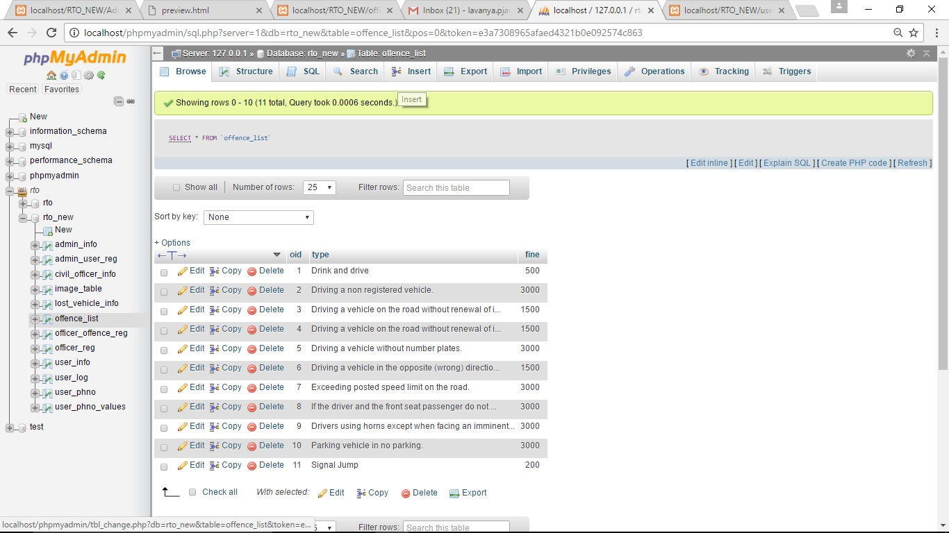

**OFFENCE_REG FORM:**

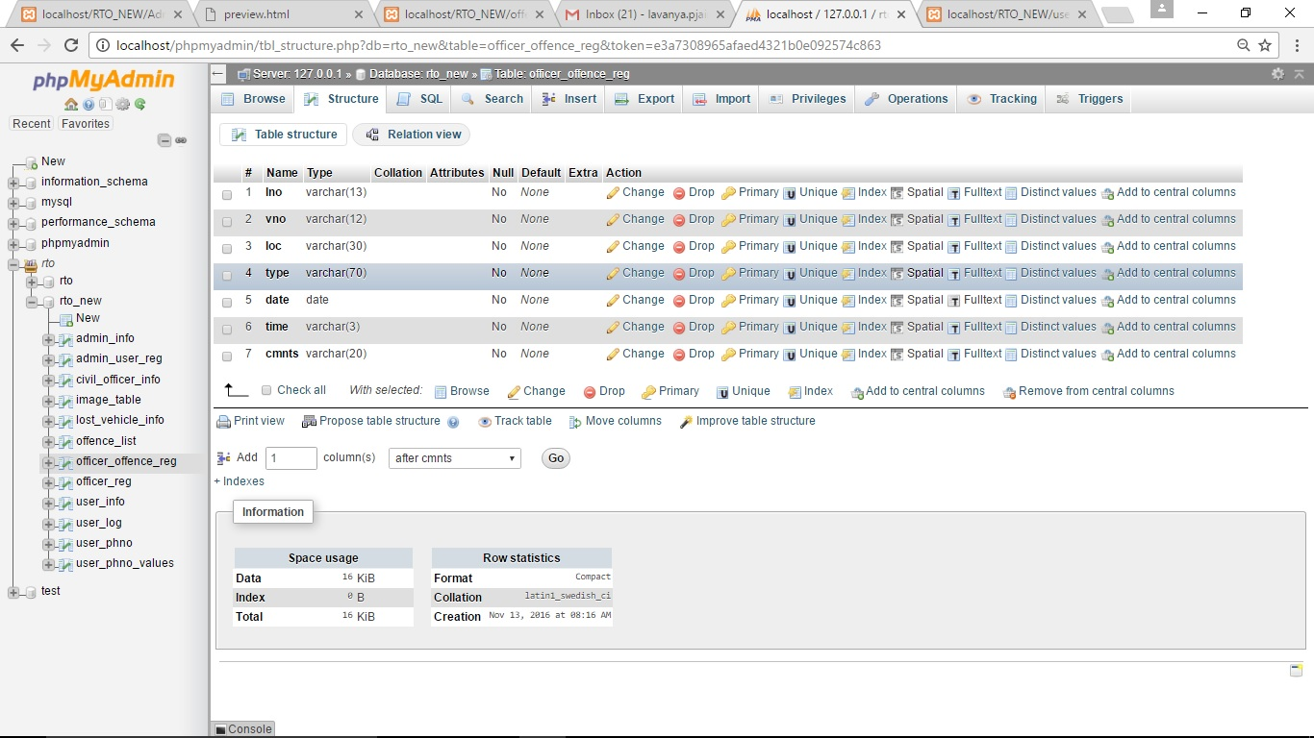

**OFFICER_INFO FORM:**

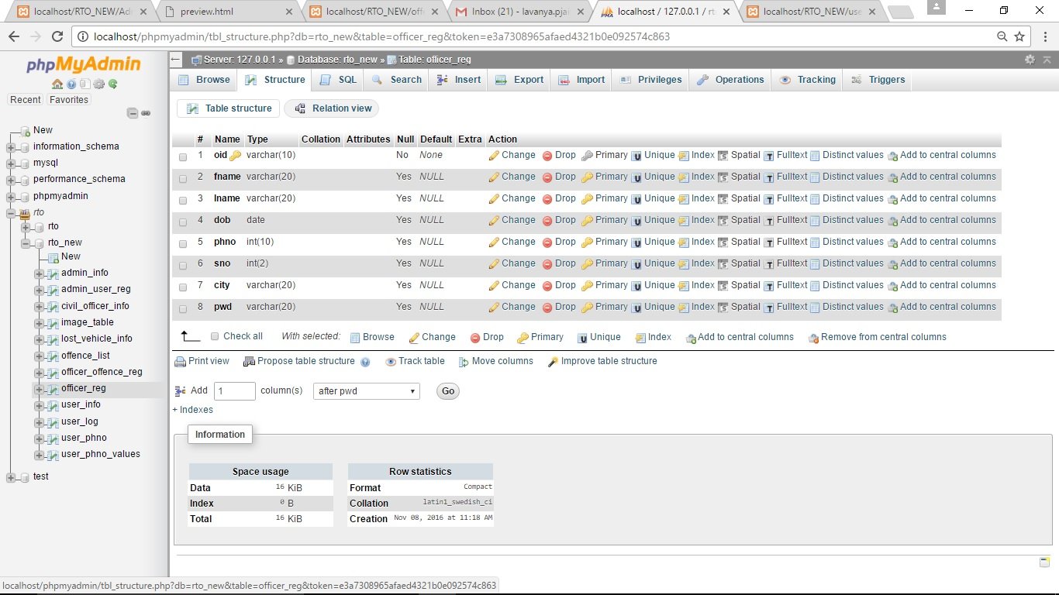

**USER_LOG FORM:**

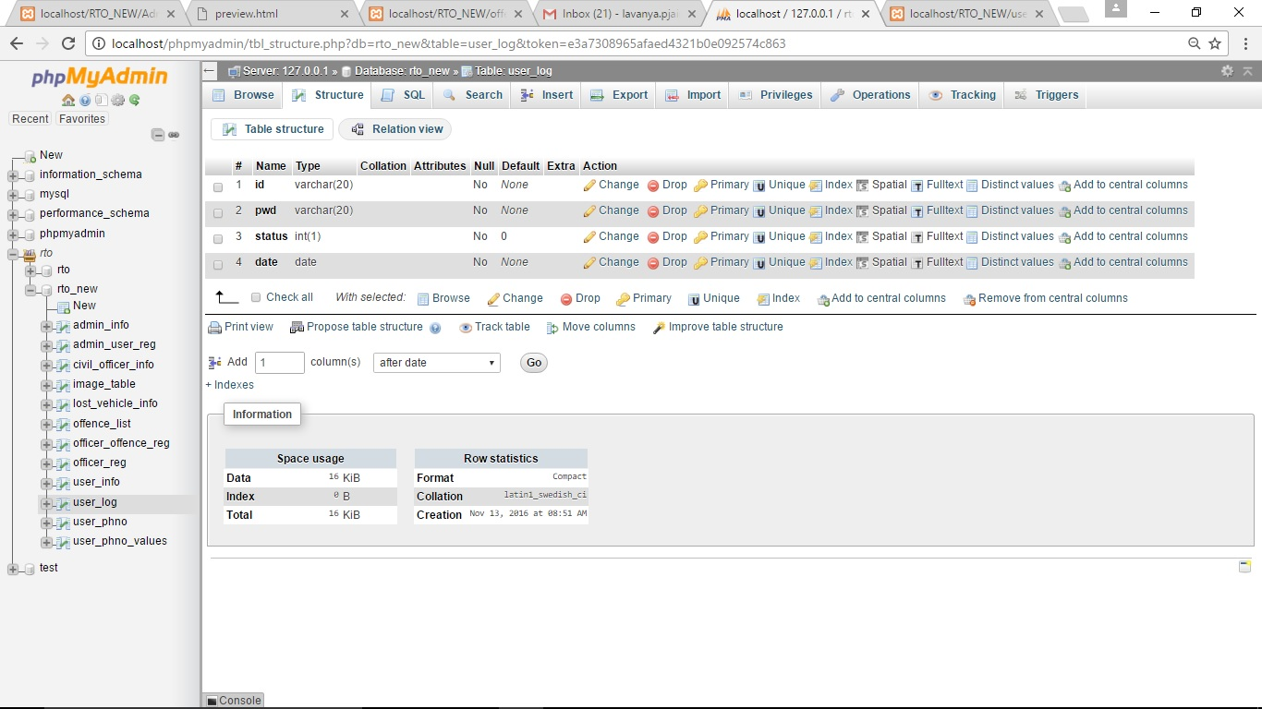

**USER_PH_TABLE FORM:**

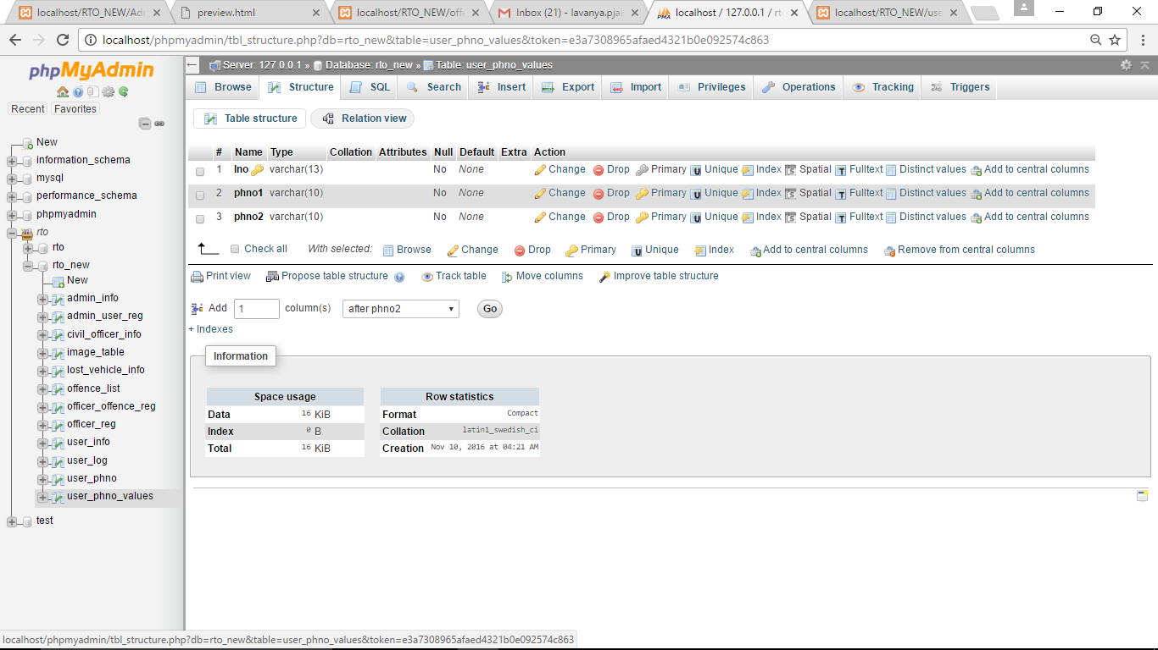

**CONCLUSION**:

It can be concluded that “Cross Verification of Driver and License for RTO”, effectively verifies documents related to vehicle and license. This system introduces facility for RTO officers to perform verification of license and vehicle documents. It also helps the RTO officials to maintain records systematically and reduces a lot of paper work and manual efforts. Hence drivers are totally independent of vehicle related documents. The driver’s data will be fetched from RTO server.

**FUTURE WORK:**

* The application can be enhanced with the concept of Face Recognition and Number Plate Recognition through image/camera.
* The application can be enhanced to send message to the drivers about the expiry dates of documents.
* It is a practical project, later it can dispatch the project in Real-time Environment.
* This paper can enhance the application by linking it to the Adhar Card database in order to retrieve more details of the license/vehicle owner.

**REFERENCES:**

[1] Grime Pandey, Diksha Dani, “Android Mobile Application Build on Eclipse”, International Journal of Scientific and Research Publications, Vol-4, Issue 2, Feb-2014.

[2] Manjunath S. Patil, Basavaraj K. Madagouda, Vinod C. Desai, “E-RTO Management System*”*, International Journal of Engineering Research & Technology (IJERT),Vol-2 Issue 7, July-2013.

[3] Suhas Holla, Mahima M. Katti, “Android Based Mobile Application Development and Its Security”, International Journal of Computer Trends and Technology, Vol-3 Issue 3, 2012.

[4] Robert W. Sebesta, *“*Programming the World Wide Web*”*, 4th Edition, Pearson Education, 2008.

[5] Herbert Scheldt, *“*Java the Complete Reference*”*, 7th Edition, Tata McGraw Hill, 2007.

[6] Android official web site for developing application, www.developer.andriod.com.